Midterm Project – Wire-Frames
Matthew Martin

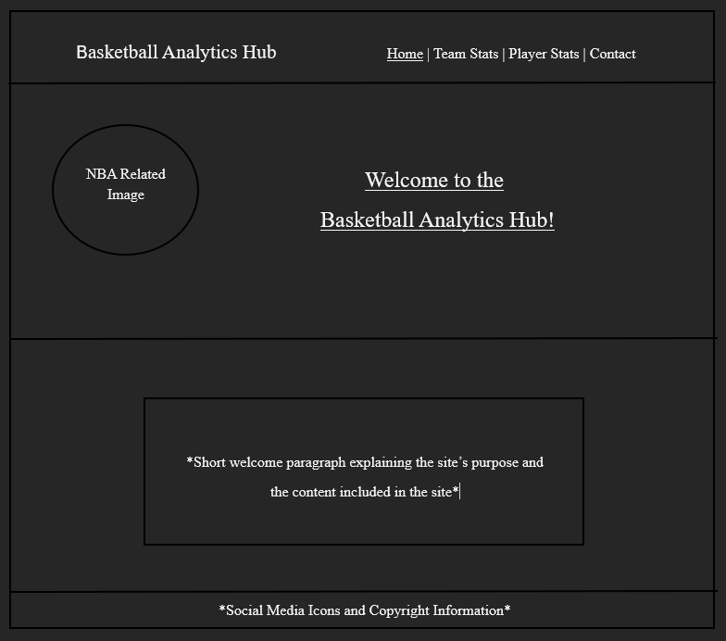
Landing Page:
Landing page including: site name, NBA/Basketball related image, nav menu, and short description of site’s purpose and content

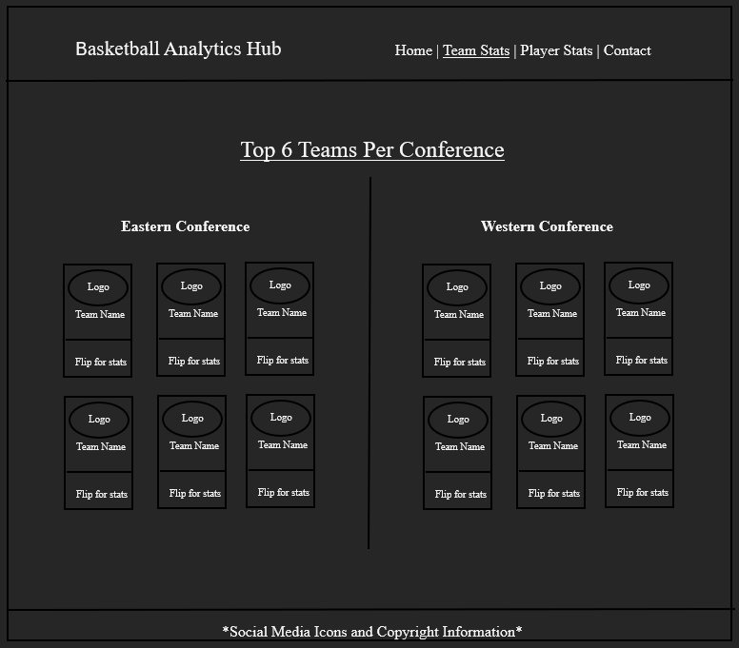
Content Page #1 (Team Stats):
Team stats page displaying the top 6 teams from each conference (eastern and western) using flip cards arranged in two rows of 3 card for each side.

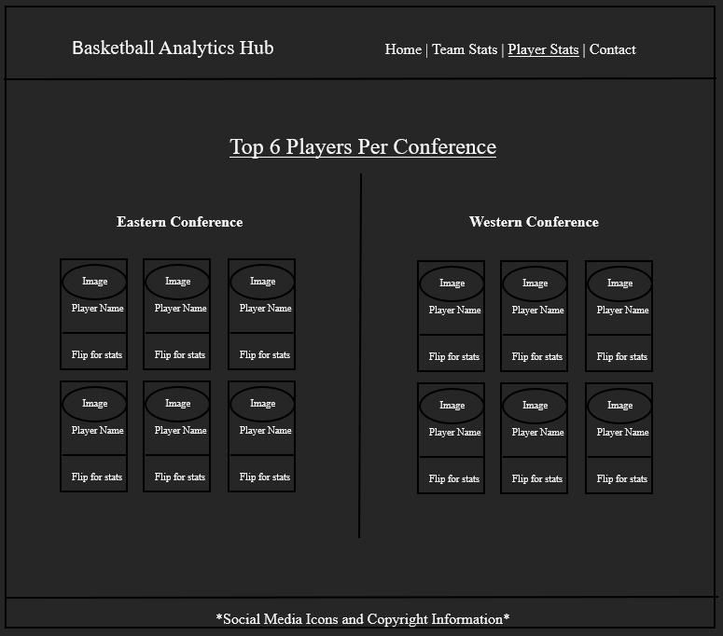
Content Page #2 (Player Stats):
Player stats page displaying the top 6 players from each conference (eastern and western) using flip cards arranged in two rows of 3 card for each side.

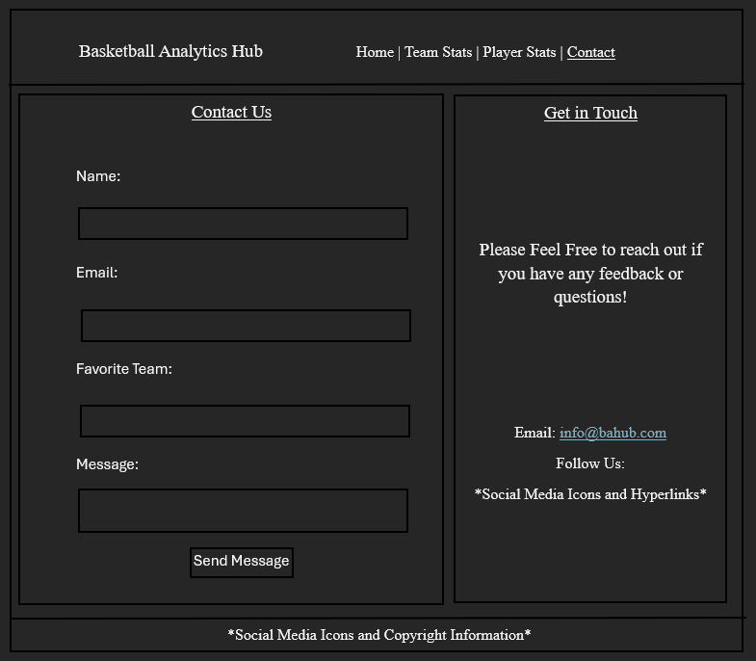

Contact Page:

Contact Page containing a form with fields for name, email, favorite team, and message. Includes the sites contact information/social media links as well.

